**Operational Concept Description (OCD)**

**Share Web**

**Team 05**

|  |  |
| --- | --- |
| Name | Role |
| Xuan Wang | Life Cycle Planner & Project Manager |
| Zhangbiaoge Tian | Developer & Operation Concept Engineer |
| Haoliang Gao | Developer & Requirement Analyst |
| Xi Chen | Developer & System Architect |
| Chuhan Zheng | Feasibility Analyst |
| Yuxuan Li | Prototyper |
|  |  |

12/01/2016

**Version History**

|  |  |  |  |  |
| --- | --- | --- | --- | --- |
| **Date** | **Author** | **Version** | **Changes made** | **Rationale** |
| 10.10.2016 | ZT | 1.0 | * Add section 1, section 2, and section 3.1, 3.2, 3.3 | * Initial Draft before presentation |
| 10.14.2016 | ZT | 2.0 | * Add Section 3.4 | * All sections now have a draft |
| 10.17.2016 | ZT | 2.1 | * Revised section 2.3, section 3.3.1 | * Correction * Modify System Boundary and Environment diagram * Modify Element Relationship diagram |
| 11.16.2016 | XW | 2.2 | * Revised section 3.2.1 | * Some of the capacities need specify, more description is added for Capability goals |
| 12.01.2016 | ZT | 2.3 | * Revised section 2.1, 2.3 | * Changed the typos in those diagram according to TA’s feedback |

**1 Introduction**

* 1. **Purpose of the OCD**

This document provides, in detail, the shared vision and goals of the stakeholders of the project Share Web. This project will be used by Rigo Garcia and his team. The main success-critical stakeholder is Rigo Garcia who is the project owner. The other stakeholders are the USC CSCI577A development team, which is responsible for the developing the project; maintainer team, which is responsible for the future updating and maintaining task for the web-sites and also the users of the Share Web.

* 1. **Status of the OCD**

The status of the OCD is currently at the version number 1.0 in the beginning of foundation phase. The current system has been analyzed and operational concept of current system has been accessed. The scope of the new system is to improve the process of building up projects and turn whole program into an integrated internet system. The document is updated as per exit criteria of the Foundation Commitment Review.

**2. Shared Vision**

**Table1: The Program Model**

|  |  |  |  |
| --- | --- | --- | --- |
| **Assumptions:**   * People want to share picture * People want download the shared picture * People want to upload a lot of pictures * People want to download the picture but phone’s storage is not enough * People want to see high resolution * People want to see picture on big screen | | | |
| **Stakeholders**  **(Who?)** | **Initiatives**  **(What?)** | **Value Propositions**  **(Why?)** | **Beneficiaries**  **(For Whom?)** |
| * Developers * Client * Users * Software maintainers | * Developers develop the system. * Maintainers maintain the system. * Users test and use the system. * Client marketing the system. | * Increase the efficiency of the Share app. * Increase the size of picture people can upload. * Increase the quality of the picture. * Increase the set of potential users. | * Users * Client |

**2.1 Benefits Chain**

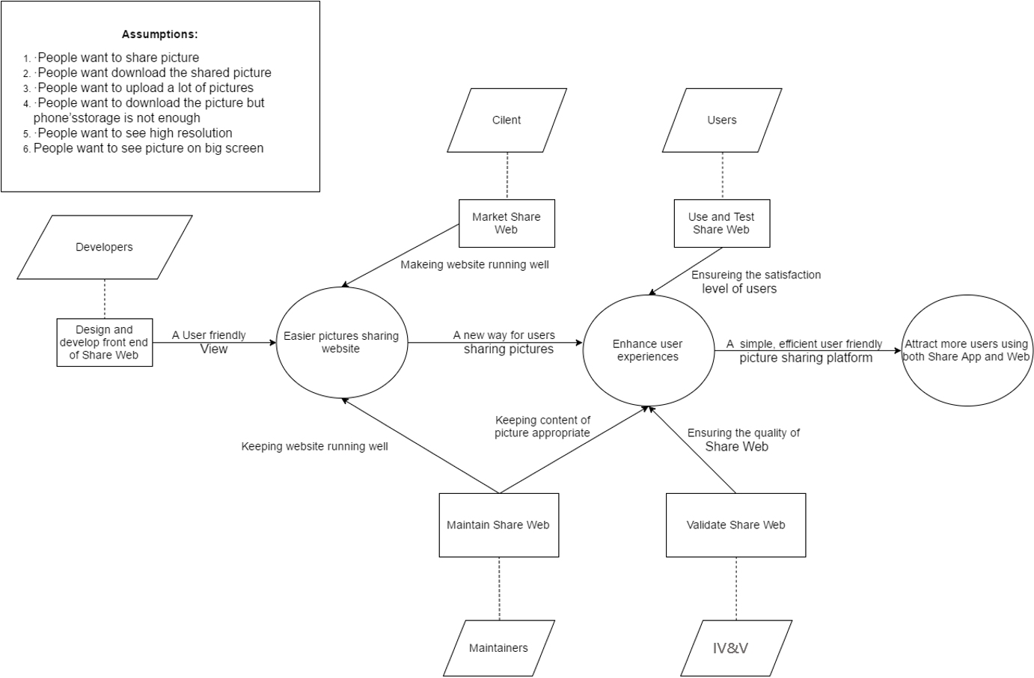

**Figure1: Benefit Chain Diagram**

**2.2 System Capabilities Description**

The Share Web is the web version of Share app, which provides users with uploading high resolution pictures, downloading pictures in their own laptop to bypass the storage limit of mobile device so that it can attract more users using both Share application and website. The Share Web mainly targets people with casual use and professional use (photographers), on the age of 16-60. In the beginning of Share deployment, Share Web only focus on USC student. Share Web provides two functions for users, uploading/downloading a lot of high resolution pictures and search pictures they are interested in.

Even though there are many picture sharing social websites in the market like Instagram and Pinterest, Share Web has its own unique features such as downloading pictures easily and uploading high resolution pictures. When people login Share web, unlike Instagram and Pinterest which people must install third party software to download pictures that they like, they can download pictures just clicking the download button in Share Web, upload higher resolution pictures than that in Instagram and Pinterest. Besides, except the compressed low resolution pictures from share mobile app, people also can download higher resolution pictures in Share Web. At the same time, Share web have the same features with the most popular social sharing website having, like comment, like, report pictures and search pictures by event.

**2.3 System Boundary and Environment**

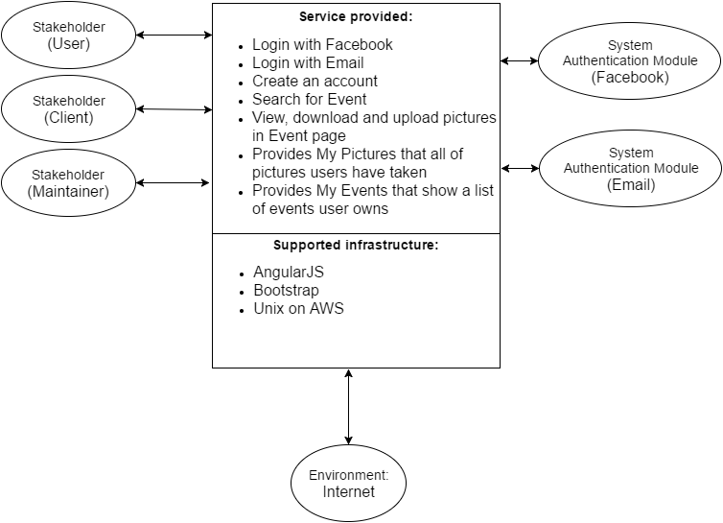

**Figure2: System Boundary and Environment Diagram**

**3. System Transformation**

**3.1 Information on Current System**

**3.1.1 Infrastructure**

There is only a homepage about Share application (<https://theshareapp.co>), no other information about Share website you can find through that URL. The back end of Share Web is completed by Rigo and his developing team. The website server is running on the AWS (Amazon Web Services). And they built a RESET API to retrieve and save all data from database for mobile use and web use as well. We can use them directly, if there are some functions need to modify the API in future, we will discuss with Rigo.

**3.1.2 Artifacts**

Since there is only a back end of Share web that we can’t run and a homepage about Share mobile application. No actual artifact was created was created by the current system.

**3.1.3 Current Business Workflow**

Like 3.1.2 Artifacts, we choose Share App as our current business workflow model.

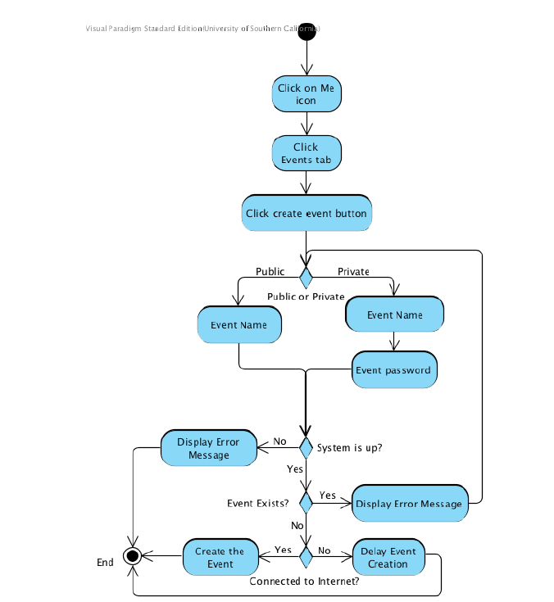

**Figure 3: Current create event workflow**

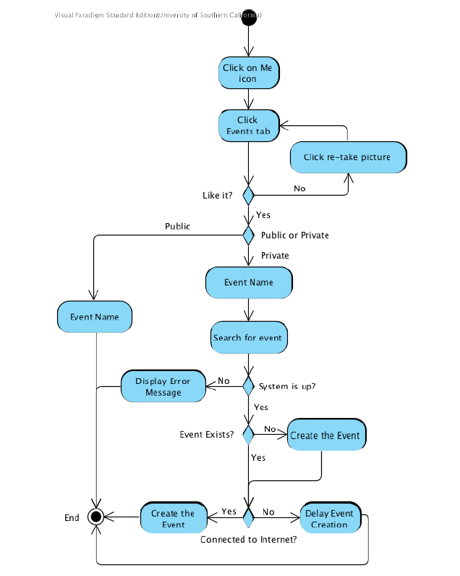

**Figure 4: Current share picture to an event workflow**

**3.2 System Objectives, Constraints, and Priorities**

**3.2.1 Capability goals**

**Table 2: Capability goals**

|  |  |  |
| --- | --- | --- |
| **ID** | **Capability goals** | **Priority level** |
| OC-1 | **Login:** user can login using Email address. | Must Have |
| OC-2 | **Logout:** user can logout the system. | Must Have |
| OC-3 | **Login with Facebook:** user can login with their Facebook account | Must Have |
| OC-4 | **Create event:** user can create an event, both public and private | Must Have |
| OC-5 | **Search event:** user can search an event by event name | Must Have |
| OC-6 | **Delete event:** user can delete the event the user creates | Must Have |
| OC-7 | **Sort by time:** user can sort pictures based on the upload time | Must Have |
| OC-8 | **Sort by popularity:** user can sort pictures based on the popularity | Must Have |
| OC-9 | **Download:** user can download one or multiple pictures | Must Have |
| OC-10 | **Upload:** user can upload one or multiple pictures | Must Have |
| OC-11 | **Delete picture:** user can delete the picture the user uploaded | Must Have |
| OC-12 | **Report picture:** user can report a picture | Should Have |
| OC-13 | **Like picture:** user can like a picture | Should Have |
| OC-14 | **Comment:** user can comment a picture | Should Have |
| OC-15 | **Delete Comment:** user can delete the comment the user made | Potentially Have |
| OC-16 | **Change view type:** user can change the view types of picture while browser pictures | Potentially Have |
| OC-17 | **Extend event:** user can extend an event with extra charge | Potentially Have |

**3.2.2 Level of Service Goals**

**Table 3: Level of service goals**

|  |  |  |  |
| --- | --- | --- | --- |
| **LOS Goals** | **Desired Level** | **Acceptance level** | **Notes** |
| Los-1: Supported bowsers: | Chrome, Safari, IE, Firefox, Edge, Avant | Chrome, Safari, IE, Firefox | WC_3989 |
| Los-2: Picture format to upload | Jpeg, PNG, Gif, Jpg, Raw | Jpeg, Raw | WC_3934 |
| Los-3: View types of picture | Small icon, Large icon, Extra-large icon, List | Small icon, Large icon | WC_3982 |

**3.2.3 Organization Goals**

**Table 4: Organization goals**

|  |  |
| --- | --- |
| **ID** | **Organization Goal** |
| OG-1 | Attract more users using both Share app and web sharing picture |
| OG-2 | Handle (download or upload) high resolution pictures easier |
| OG-3 | Handle (download or upload) a lot of pictures without installing 3rd party software |
| OG-4 | Improve user experiences in sharing pictures |
| OG-5 | An easier way to share pictures |

**3.2.4 Constraints**

Constraints are as follow:

**Table 5: Constraints**

|  |  |
| --- | --- |
| **ID** | **Constraint** |
| CO-1 | **Facebook/Email Login**:user should be able to using Facebook account / Email address to login our system |
| CO-2 | **AWS as web service provider**: use amazon web service to hold the website |
| CO-3 | **AngularJS and Bootstrap as Development Framework**: AngularJS and Bootstrap must be used as a development framework**.** |
| CO-4 | **Zero monetary budget**:The selected NDI/NCS should be free or no monetary cost. |

**3.2.5 Relation to current system**

Since there is no actual current system, we use the Share application as current system. And the relationship between current system (Share app) and new system is as follow:

**Table 6: Relation to current system**

|  |  |  |
| --- | --- | --- |
| Capabilities | Current system | New system |
| Roles and responsibilities | User can create event, upload and download compressed pictures to an event, handle pictures (comment, like, report, delete). | User can create event, upload and download one or many high resolution pictures at one time, view picture on big screen, sort pictures based on uploaded time and popularity. |
| User interactions | * Cannot view high resolution picture. * Cannot upload picture in specified format. * Cannot download high resolution picture. | * Can view high resolution picture on big screen. * Can upload picture in JPEG, PNG, GIF, RAW, JPG format. * Can download one or many high resolution pictures at one time. |
| Infrastructures | Mobile application, database, server | Online website, database, server |
| Stakeholder Essentials and Amenities | Easier way of sharing pictures. | Simple and easy way for sharing picture online, attracting more people using both Share mobile version and online version |
| Future Capabilities | N/A | N/A |

**3.3 Proposed New Operational Concept**

**3.3.1 Element Relationship Diagram**



**Figure 5: Element Relationship Diagram**

**3.3.2 Business Workflows**

Since we have a lot of workflow, we pick 3 of them to show, which are as follow:



**Figure 6: Create Event Workflow**



**Figure 7: Upload picture Workflow**



**Figure 8: Download picture Workflow**

**3.4 Organizational and Operational Implications**

**3.4.1 Organizational Transformations**

* The need to hire new maintainer rather than those for mobile app and back end to maintain the front end of Share Web incrementally.

**3.4.2 Operational Transformations**

* User will receive error message from system admin in Share Web when they invoke some fault sharing picture.
* User can choose the size of picture they want to download when using Share Web.